**CST8253 Web Programming II**

Lab 8

# Objective

1. Use ASP.NET Validation Controls
2. Use ASP.NET Session State

# Due Date

See Canvas posting for the due date of this lab. To earn 5 points, you are required:

1. Complete the lab as required.
2. Zip the web site folder and submit the zipped file to the Canvas.
3. Demonstrate your lab work.

**Requirements**

Download from Canvas Lab8.zip. Unzip Lab8.zip to get a partially completed website, **Lab8**.

**Note:**

* Study and use the supplied CSS file “SiteStyles.css” in App_Theme folder to style your web page. It is required to style your web page.
* Study class **Customer** defined in App_Code folder. Specifically the following two static methods:

Use **GetAllCustomers( )** method to get a list of customers.

Use **GetCustomerById(string id)** method to get a customer with you have the ID of the customer.

* Study and use the classes **Customer**, **Account, SavingAccount, CheckingAccount** , **Transaction** and **TransferTransaction** defined in Entities folder inside App_Code folder to complete your implementation of the website.

You are required to complete this ASP.NET website which has the following pages:

1. **FundTransferFrom.aspx**

This is the first page of the website. It has the following elements:

* A dropdown list for the user to select a transferor.
* A radio button list for user to select from which account to transfer money.
* A text box for user to enter transfer amount.

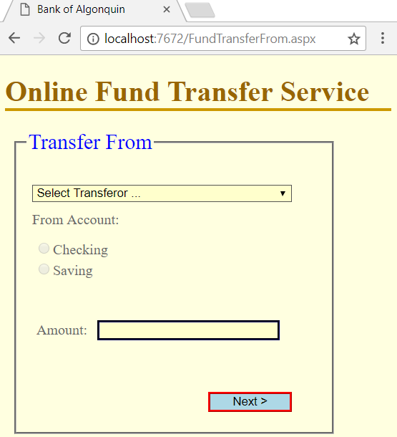

Once the user selected a transferor from the dropdown list, the page shows the balances of the transferor’s checking and saving accounts to let the user select an account and enter an amount to transfer:

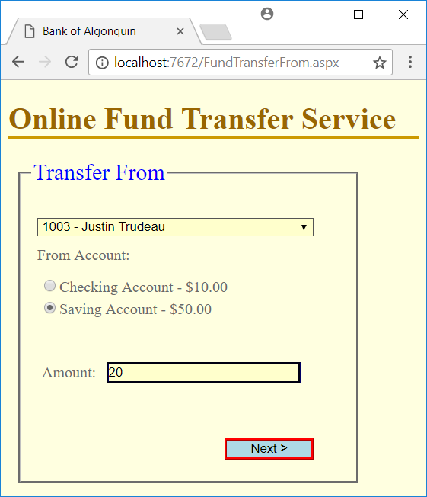

The page has the following validation rules:

* The user must select a transferor.
* The user must select an account to transfer from
* The user must enter an amount to transfer
* The transfer amount must greater than 0.
* The transfer amount must be less than or equal to the balance of the account.
* If the transfer is from check account and the transferor is a REGULAR customer, the transfer amount cannot be greater than **MaxTransferAmount** ($300). There is no transfer limitation on PRIMIER customers. A PRIMIER customer is a customer whose saving account has a balance more than **PrimierAmount** ($3000).

If one or more above validation rules fail, the page displays error messages when the user clicks the **Next** button:

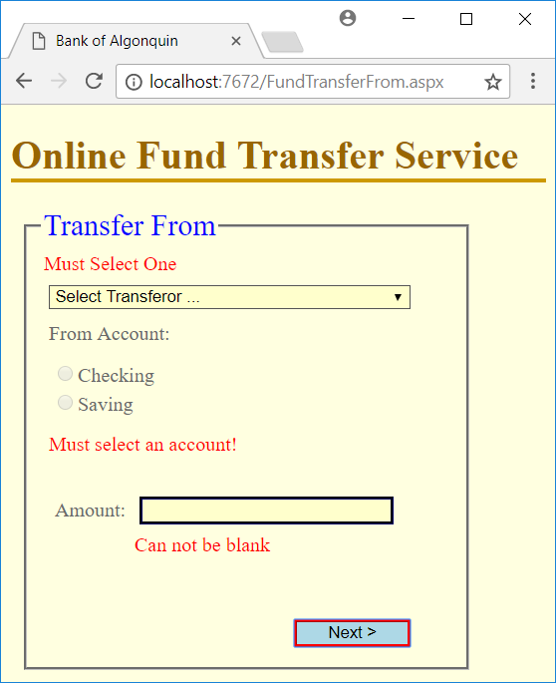

If the user inputs pass the validation rules, the website navigates to **FundTransferTo** page when **Next** button is clicked.

1. **FundTransferTo.aspx**

This page let the user select a transferee from a dropdown list and select an account to transfer the money into:

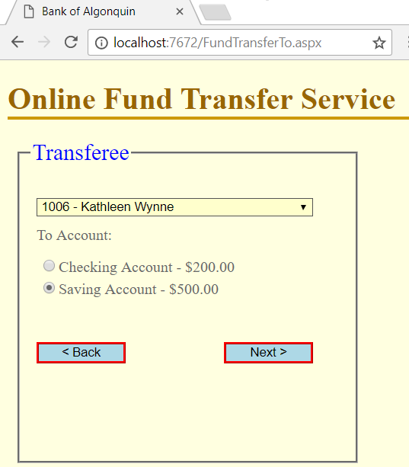

The following business rules apply to the page:

* The transferee dropdown list should not contain the transferor to prevent from transferring to the same customer.
* The user must select a transferee and an account to transfer money into. If the user fails to do so when clicking the **Next** button, the page will present related error messages.

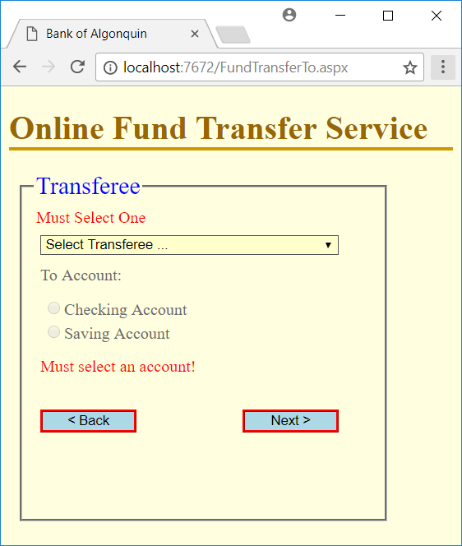

* At any time, the user can click the **Back** button to go back to the previous page; **FundTransferFrom** to change transferor, account and amount. **FundTransferFrom** must prefilled with the user’s previous entered data.

If the user entries are all valid, the website navigates to **FundTransferConfirmation** page when **Next** button is clicked.

1. **FundTransferConfirmation.aspx**

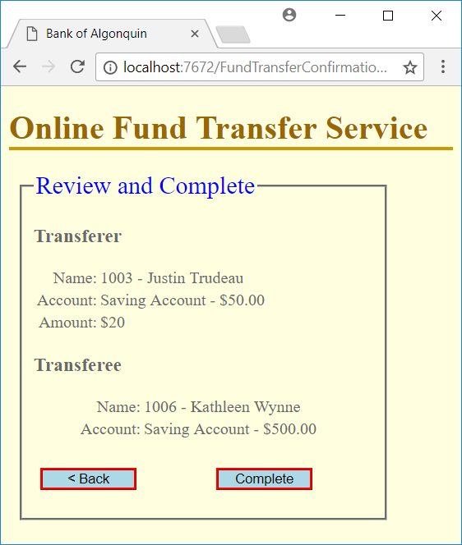

This page shows the data the user entered on the previous two pages. The user can click **Back** button to the previous page to modify, or click Complete button to finish the transfer fund.

When using **Back** or **Next** buttons to navigate between pages, the website must maintain the user’s previously entered data.

1. **FundTransferResult.aspx**

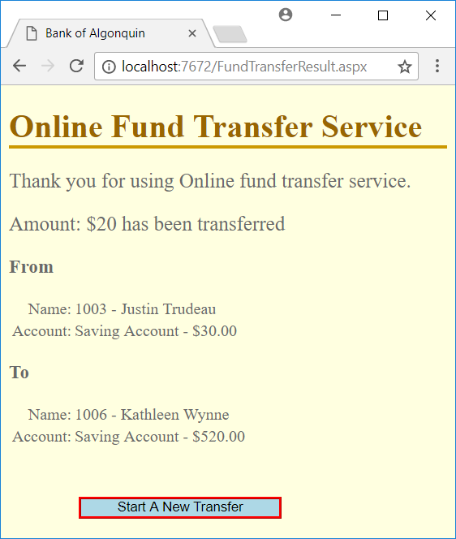

This page shows the fund transfer results, the new balance of transfer from account and that of the transfer to account.

The user can click Start A New Transfer button to go back to the first page **FundTransferFrom** page to start a new transfer.